NAIT

Edmonton, Alberta

**Raspberry Pi Security Camera**

**User’s Manual**

Submitted To

Marc Anderson, CMPE2960 CNT Instructor

Kelly Shepherd, CMPE2960 CNT Instructor

Submitted by

Alaam Amershi, CMPE2960 Student

Xiao Liu, CMPE2960 Student

**About this Manual**

This user manual has been designed to help you make the most of your IP camera and its many features and functions.

Information in this document has been carefully checked for accuracy; however, no guarantee is given to the correctness of the contents. The information in this document is subject to change without notice.

**Copyright**

© Copyright 2018

This manual contains proprietary information, protected by copyright. All rights reserved.

**Caution**

* Do not clean the camera with wet cloth.

**Key Features**

* 640x480 (VGA), 320x240 (QVGA), 160x120 (QQVGA) resolutions
* 307,200 effective pixels
* Framerate 30fps at VGA resolution
* 3.6 mm, F2.0 lens
* Configuration and viewing via standard internet browser
* Automatic infrared night vision function
* External GPIO Servo Control for tiling and rotation

**Parts List**

* RaspberryPi 2
* SG 90 Micro Servo X2

**Software List**

* Apache 2 web server with PHP module
* Python
* Codeignitor Framework Library for login website

**Using and Configuring**

* Connect Raspberry Pi to Monitor via HDMI cable
* Plug the Raspberry Pi into 110V/220V power outlet with supplied power adapter
* Open Pi browser type in 127.0.0.1 in address bar
* Register a user following the Register link
* Login with registered credential

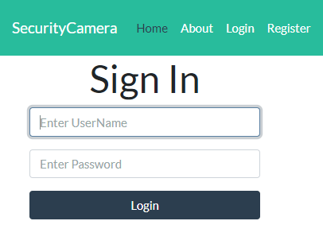

* Upon successful login, camera controller page will be shown
* Click and drag the scroll bar to tilt and pan the camera